MOHANLAL SUKHADIYA UNIVERSITY, UDAIPUR
INFORMATICS & COMPUTATIONAL SCIENCE PROGRAMME



BACHELOR OF COMPUTER APPLICATION
BCA VI Sem 2025-26

Submitted To: Submitted By:
Dr Avinash Panwar Aaditya Prajapat

AnchorPay
Anchor Your Finances,Anytime



AnchorPay — A Production-Grade Spring Boot Fintech Backend for Digital Wallet Management and Secure Payment Operations

Description of Progress made with Screenshots:
- Introduction
AnchorPay is a fintech backend application built using Java Spring Boot, designed to simulate core digital wallet and payment functionalities. The project demonstrates proficiency in backend development, implementing industry-standard security practices, RESTful API design, and database management.

2. Project Objectives
- Design and develop a secure REST API backend for a digital wallet system
- Implement JWT-based authentication with Redis token storage
- Build wallet management features including balance check and money transfer
- Apply BCrypt password encryption for secure credential storage
- Implement role-based access control for User and Admin endpoints
- Design clean and consistent API responses using standard response format

3. Package Structure
The project follows a layered architecture with clearly separated packages — controller, service, repository, entity, dto, config, exception, and response — ensuring clean code and separation of concerns.
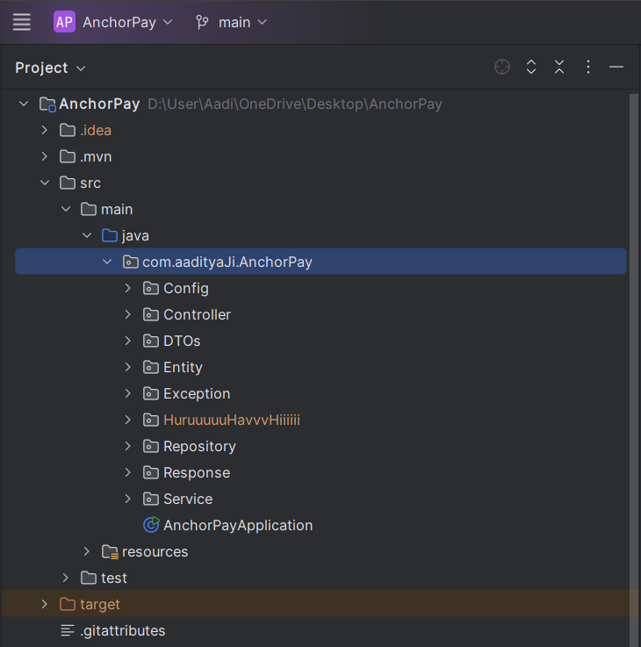


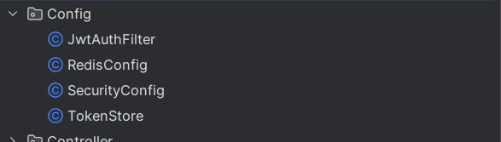


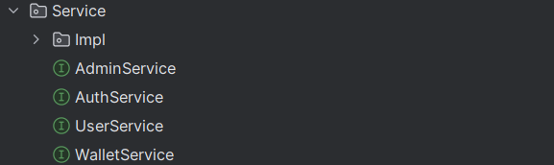

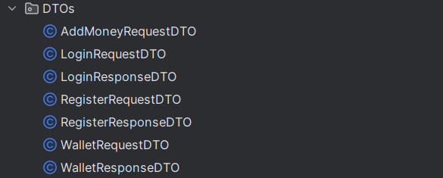
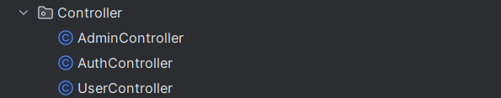



4. Authentication Module
A complete authentication system was implemented including User Registration with BCrypt password encryption, email uniqueness validation, and auto wallet creation on registration. JWT-based login generates a secure token stored in Redis with TTL expiration. Logout invalidates the token from Redis. A custom JwtAuthFilter validates every incoming request before it reaches the controller.

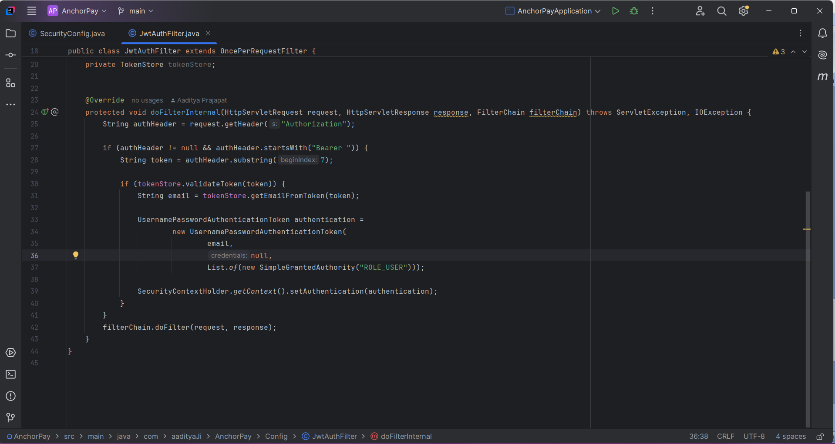

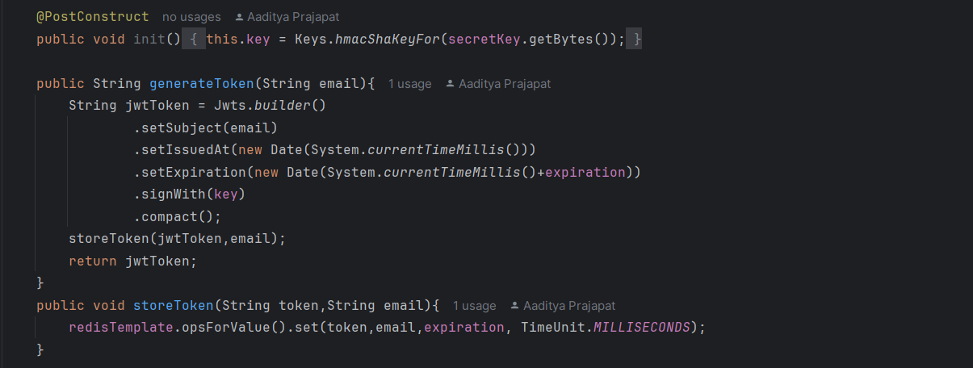

5. Security Configuration
Spring Security was configured with a stateless session policy. Public endpoints (/api/auth/**) are accessible without authentication. User endpoints (/api/user/**) require USER role and Admin endpoints (/api/admin/**) require ADMIN role. The JwtAuthFilter is registered before Spring's default authentication filter.

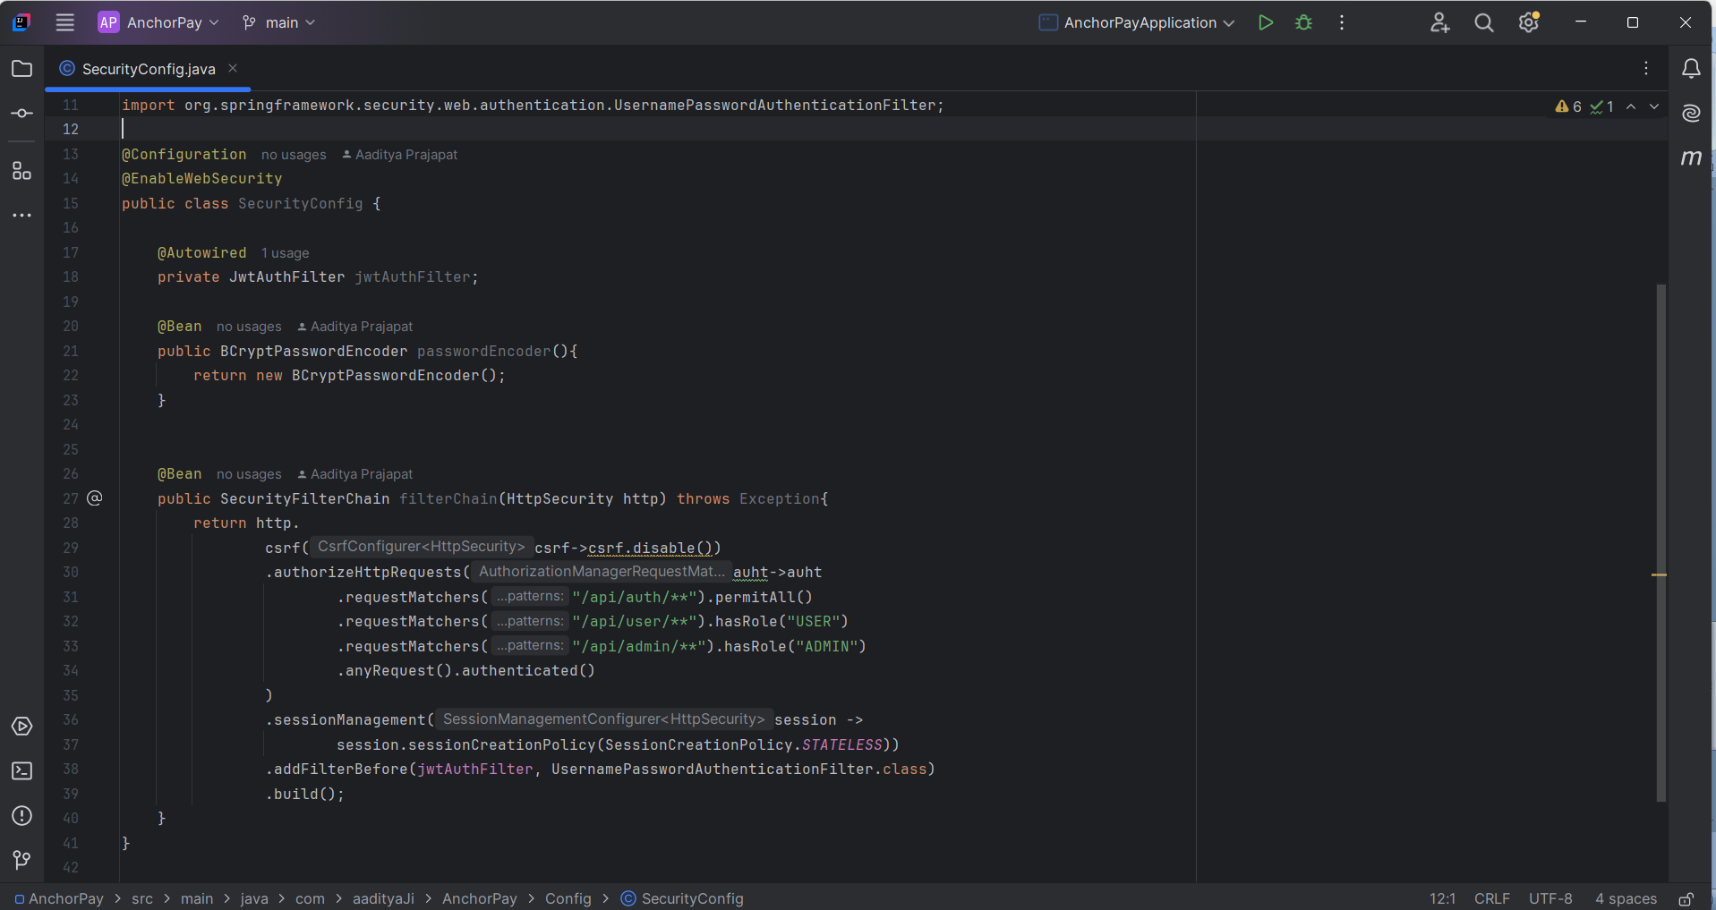

6. Wallet Module
Wallet is automatically created upon user registration with zero balance. Check Balance endpoint retrieves current wallet balance using SecurityContextHolder — no additional user input required. Add Money endpoint updates wallet balance using BigDecimal precision arithmetic ensuring accurate financial calculations.
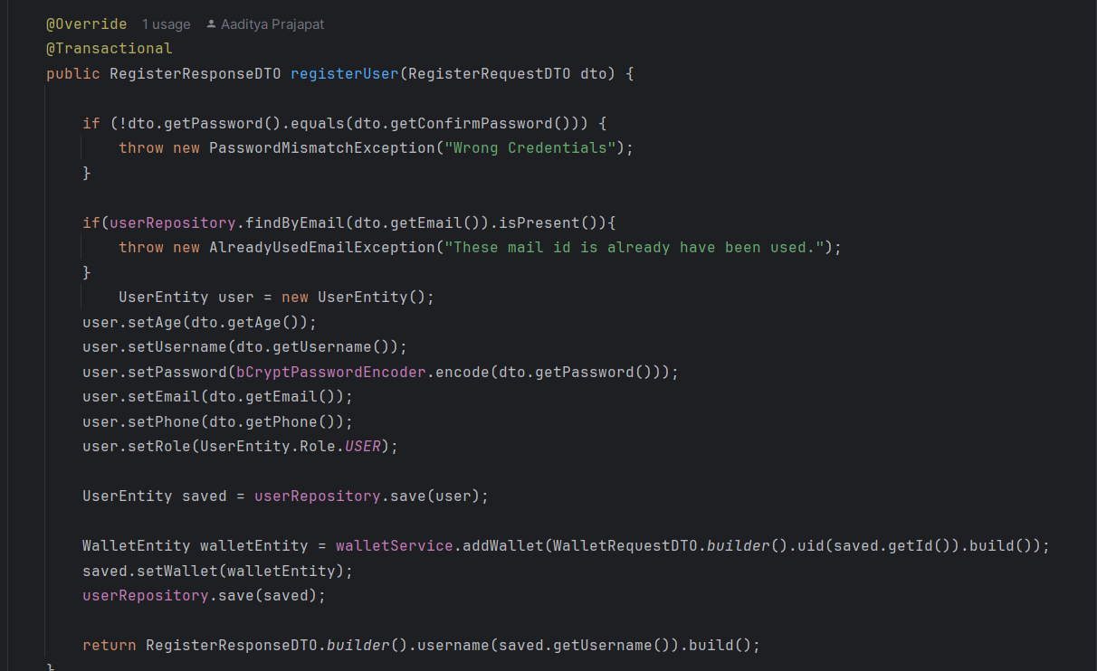

7. Comments of the Instructor:

